**MICRO PROJECT ON**

**‘REPORT ON CONSTRUCT BCD TO 7 SEGMENT DECODER’**

**Course: Digital Technique**

**Corse Code: 22320**

**Academic Year: 2023-2024 Semester: 3I**

**Submitted By:**

|  |  |  |
| --- | --- | --- |
| **Roll No.** | **Name of the student** | **Enrollment No.** |
| 1525 | Shubham Dinesh Giri | 2201410262 |
| 1526 | Rushi Raviraj Gujarathi | 2201410263 |
| 1527 | Param Bhimrao Jadhav | 2201410267 |

**Name of Project Guide: Mrs. C.M.Maind**



# CERTIFICATE

This is to certify that this micro project report titled **‘REPORT ON CONSTRUCT BCD TO 7 SEGMENT DECODER’** is the bonafide work of Ms./Mr.**Shubham Giri , Rushi Gujarathi, Param Jadhav**  Roll no : 1**525 – 1527** of second year diploma in **Computer** Engineering for the course ‘Digital Techniques’ Course code: **22320** during the academic year 2023-2024 , who carried out the micro project work under my supervision.

**Mrs. C.M.Maind**

Name & Signature of Course Teacher

**INDEX**

|  |  |  |
| --- | --- | --- |
| **Sr. No.** | **Content** | **Page No.** |
| 1. | Micro Project Proposal | 10 |
| 2. | Rationale | 06 |
| 3. | Aims/Benefits of the Micro Project | 06 |
| 4. | Course Outcome achieved | 06 |
| 5. | Literature Review | 06 |
| 6. | Actual Methodology Followed | 07 |
| 7. | Actual Resources Used | 08 |
| 8. | Output of the Micro Projects | 08 |
| 9. | Skill Developed / Learning outcome of the Micro Project | 12 |
| 10. | Applications of the Micro Project | 12 |

**Micro Project Proposal**

**ANNEXURE I**

**‘REPORT ON CONSTRUCT BCD TO 7 SEGMENT DECODER’**

* 1. **1.0 Aims/Benefit of the Micro Project** (Minimum 30-50 Words)**:**

1. Test seven segment display.
2. Assemble the circuit on breadboard.
3. Make connections as per circuit diagram.

## 2.0 Course Outcomes Addressed:

* 1. **C22320.c.** Build simple combinational circuits.
  2. **3.0 Proposed Methodology** (Procedure that will be followed to do the micro project- in about 100-200 words)**:**

1. Search and Collect information
2. Arrange information
3. Proofread the information
4. Review from the teacher
5. Edit project report as per the suggestions of the teacher
6. Proofread and finalize the report
7. Finalize from the teacher
8. Take Print and Submit of the report

## 4.0 Action Plan:

|  |  |  |  |  |
| --- | --- | --- | --- | --- |
| **Sr.**  **No.** | **Detail of Activity** | **Planned Start date** | **Planned Finish**  **Date** | **Name of Responsible Team Members** |
| **1.** | Search and Collect information | 24/07/2023 | 24/07/2023 | Rushi Gujarathi |
| **2.** | Arrange information | 27/08/2023 | 27/10/2023 | Param Jadhav |
| **3.** | Proofread the information | 01/09/2023 | 01/09/2023 | Shubham Giri |
| **4.** | Review from the teacher | 10/09/2023 | 10/09/2103 | All members |
| **5.** | Edit project report as per the  suggestions of the teacher | 24/10/2023 | 24/10/2023 | Rushi Gujarathi,Shubham Giri |
| **6.** | Proofread and finalize the report | 11/11/2023 | 11/11/2023 | Param Jadhav |
| **7.** | Finalize from the teacher | 13/11/2023 | 13/11/2023 | All Members |
| **8.** | Take Print & Submit of the  Report | 20/11/2023 | 20/11/2023 | All members |

**5.0 Resource Required:**

|  |  |  |  |  |
| --- | --- | --- | --- | --- |
| **Sr. No.** | **Name of Resource/Material** | **Specification** | **Qty.** | **Remark** |
| 1. | Internet/ websites | https://www.geeksforgeeks.org/bcd-to-7-segment-decoder/ | **---** | **---** |
|  |  | * + 1. https://www.engineersgarage.com/common-anode-and-cathode-7-segmentdisplay/#:~:text=Seven%20segment%20display%20is%20composed,common%20anode%207%20segment%20display. | **---** | **---** |
|  |  | <https://www.geeksforgeeks.org/seven-segment-displays/> | **---** | **---** |
| 2. | Youtube | * + 1. https://www.youtube.com/watch?v=CQ9iEImgyQo. | **---** | **---** |
| 3. | Connecting Wires | * + 1. Single strand 0.6mm Teflon coating | As required | **---** |
| 4. | 7 segment Display | * + 1. IC FND507/LT 542 | **1** | **---** |
| 5 | IC | * + 1. 7447 | **1** | **----** |
| 6. | 0 Pcb Board | * + 1. 4*4 | **1** | **----** |

## Name of Team Members with Roll Nos:

|  |  |  |
| --- | --- | --- |
| **Sr. No** | **Name of Students** | **Roll No** |
| 1 | Shubham Dinesh Giri | 1525 |
| 2 | Rushi Raviraj Gujarathi | 1526 |
| 3 | Param Bhimrao Jadhav | 1527 |

**Mrs. C.M.Maind**

**(Name & Signature of Faculty)**

**ANNEXURE I**

**Micro Project Report**

**‘REPORT ON CONSTRUCT BCD TO 7 SEGMENT DECODER’**

1. **Rationale** (Importance of the project, in about 30 to 50 Words.)**:**

In the present scenario most of the electronic equipment like computers, mobiles, music systems, ATM, automation and control circuits and systems are based on digital circuits which the diploma electronic engineering pass outs (also called technologists) must test them. The knowledge f basic logic gates, combinational and sequential logic circuits using discrete gates as well as digital ICs will enable the students to interpret the working of equipment and maintain them. After completion of the course, students will be able to develop digital circuits based applications.

## Aims/Benefits of the Micro Project:

1.Test seven segment display.

2.Assemble the circuit on breadboard.

3.Make connections as per circuit diagram.

## Course Outcomes Addressed:

1. **C22320.c.** Build simple combinational circuits.

## 4.0 Literature Review:

1. **Information about 7 segment display** : https://www.geeksforgeeks.org/bcd-to-7-segment-decoder/
2. **Working of 7 segment displays**: https://www.engineersgarage.com/common-anode-and-cathode-7-segmentdisplay/#:~:text=Seven%20segment%20display%20is%20composed,common%20anode%207%20segment%20display.
3. **BCD to 7 segment decoder**: <https://www.geeksforgeeks.org/seven-segment-displays/>
4. **Types, Advantages and Applications of 7 segment display**: <https://www.google.com/search?q=bcd+to+7+segment+decoder&source=lmns&bih=931&biw=1920&rlz=1C1CHBF_enIN1050IN1050&hl=en&sa=X&ved=2ahUKEwjX0KeR_7CBAxVNpWMGHYfEAVEQ0pQJKAB6BAgBEAI>
5. **Soldering:** https://www.youtube.com/watch?v=CQ9iEImgyQo.

**5.0 Actual Methodology Followed**: (Write stepwise work done, data collected and its analysis is (if any). The contribution of individual member may also be noted.) **:**

|  |  |  |  |
| --- | --- | --- | --- |
| **Sr. No./ Hour No.** | **Date** | **Time** | **Work Done** |
| **1.** | 24/07/2023 | 05:00 pm **-** 06:00 pm | Finalize the topic |
| **2.** | 27/07/2023 | 07:00 pm – 08:00 pm | Finalize the topic |
| **3.** | 08/08/2023 | 07:00 pm – 08:00 pm | Find and collect information |
| **4.** | 20/08/2023 | 06:00 pm – 07:00 pm | Find and collect information |
| **5.** | 28/08/2023 | 05:00 pm **-** 06:00 pm | Find and collect information |
| **6.** | 09/09/2023 | 08:00 pm – 09:00 pm | Find and collect information |
| **7.** | 15/09/2023 | 08:00 pm – 09:00 pm | Arrange the information |
| **8.** | 24/09/2023 | 08:00 pm – 09:00 pm | Arrange the information |
| **9.** | 30/09/2023 | 05:00 pm **- 0**6:00 pm | Arrange the information |
| **10.** | 08/10/2023 | 07:00 pm – 08:00 pm | Arrange the information |
| **11.** | 20/10/2023 | 06:00 pm – 07:00 pm | Proofread the information |
| **12.** | 24/10/2023 | 07:00 pm – 08:00 pm | Proofread the information |
| **13.** | 01/11/2023 | 09:10 am – 10:10 am | Review from the teacher |
| **14.** | 10/11/2023 | 05:00 pm **-** 06:00 pm | Edit project report as per suggestions of the teacher |
| **15.** | 15/11/2023 | 08:10 pm – 09:10 pm | Proofread and finalize the report |
| **16.** | 24/11/2023 | 08:10 am – 09:10 am | Submission of the report |

## 6.0 Actual Resource Used:

|  |  |  |  |  |
| --- | --- | --- | --- | --- |
| **Sr. No.** | **Name of Resource/Material** | **Specification** | **Qty.** | **Remark** |
| 1. | Internet/ websites | https://www.geeksforgeeks.org/bcd-to-7-segment-decoder/ | **---** | **---** |
|  |  | * + 1. https://www.engineersgarage.com/common-anode-and-cathode-7-segmentdisplay/#:~:text=Seven%20segment%20display%20is%20composed,common%20anode%207%20segment%20display. | **---** | **---** |
|  |  | <https://www.geeksforgeeks.org/seven-segment-displays/> | **---** | **---** |
| 2. | Youtube | * + 1. https://www.youtube.com/watch?v=CQ9iEImgyQo. | **---** | **---** |
| 3. | Connecting Wires | * + 1. Single strand 0.6mm Teflon coating | As required | **---** |
| 4. | 7 segment Display | * + 1. IC FND507/LT 542 | **1** | **---** |
| 5 | IC | * + 1. 7447 | **1** | **----** |
| 6. | 0 Pcb Board | * + 1. 4*4 | **1** | **----** |

1. **Outputs of the Micro project** (Presentation of data, findings, drawing etc.)**:**

* **What are seven segment displays?**

Seven segment displays are the output display device that provides a way to display information in the form of images or text or decimal numbers which is an alternative to the more complex dot matrix displays. It is widely used in digital clocks, basic calculators, electronic meters, and other electronic devices that display numerical information. It consists of seven segments of light-emitting diodes (LEDs) which are assembled like numerical 8.

* **There are two types of seven segment LED display:**

1. Common Cathode Type: In this type of display all cathodes of the seven LEDs are connected together to the ground or -Vcc (hence, common cathode) and LED displays digits when some ‘HIGH’ signal is supplied to the individual anodes.

2. Common Anode Type: In this type of display all the anodes of the seven LEDs are connected to battery or +Vcc and LED displays digits when some ‘LOW’ signal is supplied to the individual cathodes.

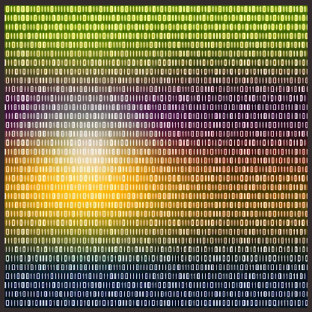

* **Working of Seven Segment Displays:**

The number 8 is displayed when the power is given to all the segments and if you disconnect the power for ‘g’, then it displays the number 0. In a seven-segment display, power (or voltage) at different pins can be applied at the same time, so we can form combinations of display numerical from 0 to 9. Since seven-segment displays cannot form alphabets like X and Z, so it cannot be used for the alphabet and they can be used only for displaying decimal numerical magnitudes. However, seven-segment displays can form alphabets A, B, C, D, E, and F, so they can also be used for representing each display unit is usually has a dot point (DP). The display point could be located either towards the left or towards the right of the display pattern. This type of pattern can be used to display numerals from 0 to 9 and letters from to F hexadecimal digits.

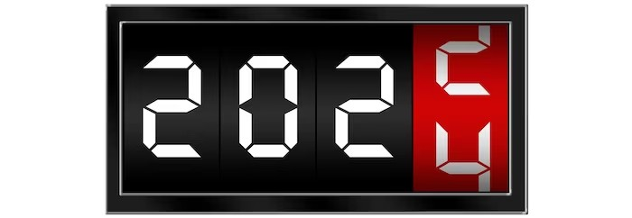

* **Truth table for BCD to 7 Segment decoder:**

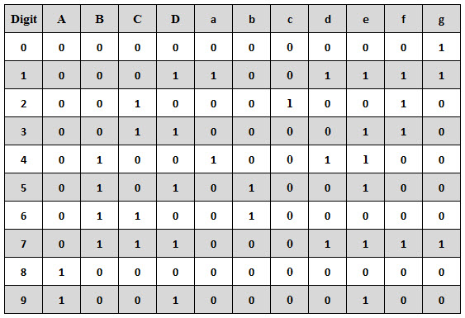

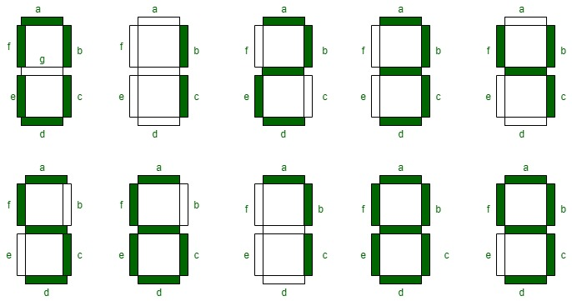

* **Common applications of seven-segment displays are:**
* Digital clocks
* Clock radios
* Calculators
* Wristwatches
* Speedometers
* Motor-vehicle odometers
* Radiofrequency indicators

1. **Skill developed / Learning outcome of the Micro-Project:**
2. Handle IC and equipment carefully.
3. Digital logic Design.
4. Understanding 7-segment displays.
5. Problem solving.
6. Circuit analysis.

## Applications of the Micro-Project:

BCD to 7-segment decoders is commonly used in digital clock displays to show hours and minutes. In digital thermometers, BCD values representing temperature can be converted and displayed on 7-segment displays, making it easier for users to read the temperature. Older calculators used BCD to 7-segment decoders to display numbers and results. They are used in educational toys and kits to teach children about numbers and basic arithmetic operations.

**Mrs. C.M.Maind**

## (Name & Signature of Faculty)

**Log Book of the Student (Weekly Work Report)**

**Academic Year: 2023-2024**

**Name of Student: Shubham Giri, Rushi Gujarathi , Param Jadhav**

**Title of the Project:** ‘Report on BCD to seven segment decoder’

**Course:** Digital Techniques **Course Code:** 22320 **Semester:** 3I

|  |  |  |  |
| --- | --- | --- | --- |
| **Sr. No./ Hour No.** | **Date** | **Time** | **Work Done** |
| **1.** | 24/07/2023 | 05:00 pm **-** 06:00 pm | Finalize the topic |
| **2.** | 27/07/2023 | 07:00 pm – 08:00 pm | Finalize the topic |
| **3.** | 08/08/2023 | 07:00 pm – 08:00 pm | Find and collect information |
| **4.** | 20/08/2023 | 06:00 pm – 07:00 pm | Find and collect information |
| **5.** | 28/08/2023 | 05:00 pm **-** 06:00 pm | Find and collect information |
| **6.** | 09/09/2023 | 08:00 pm – 09:00 pm | Find and collect information |
| **7.** | 15/09/2023 | 08:00 pm – 09:00 pm | Arrange the information |
| **8.** | 24/09/2023 | 08:00 pm – 09:00 pm | Arrange the information |
| **9.** | 30/09/2023 | 05:00 pm - 06:00 pm | Arrange the information |
| **10.** | 08/10/2023 | 07:00 pm – 08:00 pm | Arrange the information |
| **11.** | 20/10/2023 | 06:00 pm – 07:00 pm | Proofread the information |
| **12.** | 24/10/2023 | 07:00 pm – 08:00 pm | Proofread the information |
| **13.** | 01/11/2023 | 09:10 am – 10:10 am | Review from the teacher |
| **14.** | 10/11/2023 | 05:00 pm **-** 06:00 pm | Edit project report as per suggestions of the teacher |
| **15.** | 15/11/2023 | 08:10 pm – 09:10 pm | Proofread and finalize the report |
| **16.** | 24/11/2023 | 08:10 am – 09:10 am | Submission of the report |

## Mrs. C.M.Maind

## (Name & Signature of Faculty)